CLEAN AIR PHARMA: CLEANROOM ENVIRONMENT AND AIR QUALITY MONITOR
A Comprehensive Full-Stack Web Telemetry & PostgreSQL Audit Monitoring System
A PROJECT REPORT
Submitted in partial fulfillment of the requirements for the award of the degree of
BACHELOR OF TECHNOLOGY IN COMPUTER SCIENCE AND ENGINEERING
Submitted by: TEAM NO.: 18
S.No. | Student Name | Registration Number
1 | K. Harshit | 2520040035
2 | N. Karthik Ram Prasad | 2520040046
3 | M. Tirumala Teja | 2520049126

Under the Esteemed Guidance of: Dr. Karumuri Sri Rama Murthy
Assistant Professor, Department of Computer Science & Engineering KLU Hyderabad, Hyderabad
DEPARTMENT OF COMPUTER SCIENCE AND ENGINEERING KONERU LAKSHMAIAH EDUCATION FOUNDATION (KLU Hyderabad Campus, Aziz Nagar, Hyderabad, Telangana — 500075) Academic Year: 2025–2026

CERTIFICATE
This is to certify that the project report entitled "Clean Air Pharma: Cleanroom Environment and Air Quality Monitor" is a bona fide record of original academic project work carried out by:
• K. Harshit (Registration No. 2520040035) • N. Karthik Ram Prasad (Registration No. 2520040046) • M. Tirumala Teja (Registration No. 2520049126)
students of Bachelor of Technology in Computer Science and Engineering, during the academic year 2025–2026, in partial fulfillment of the requirements for the award of the degree of Bachelor of Technology in Computer Science and Engineering from Koneru Lakshmaiah Education Foundation (KLU Hyderabad).
This project work has been formally examined and approved as per the academic curriculum and evaluation standards of the university.
Faculty Project Guide | Head of the Department
___________________________________ Dr. Karumuri Sri Rama Murthy Assistant Professor, Dept. of CSE KLU Hyderabad | ___________________________________ Head of the Department Department of Computer Science & Eng. KLU Hyderabad

Internal Examiner | External Examiner
___________________________________ Internal Examiner Date: [Insert Date] Place: Hyderabad | ___________________________________ External Examiner Date: [Insert Date] [Seal of the Institution]

DECLARATION
We hereby declare that the project report entitled "Clean Air Pharma: Cleanroom Environment and Air Quality Monitor" submitted by us to the Department of Computer Science and Engineering, Koneru Lakshmaiah Education Foundation (KLU Hyderabad), in partial fulfillment of the requirements for the award of the degree of Bachelor of Technology in Computer Science and Engineering, is a genuine record of our original software development and research work.
This work has been executed under the guidance and supervision of Dr. Karumuri Sri Rama Murthy, Assistant Professor, Department of Computer Science and Engineering, KLU Hyderabad.
We further affirm that the technical material and software implementation presented in this report, in whole or in part, has not been previously submitted to any other university, institute, or examining body for the award of any degree, diploma, or certificate.
Student Candidates: 1. ___________________________________ K. Harshit (2520040035) 2. ___________________________________ N. Karthik Ram Prasad (2520040046) 3. ___________________________________ M. Tirumala Teja Naidu (2520049126)
Date: [Insert Date] Place: Hyderabad

ACKNOWLEDGEMENT
First and foremost, we express our profound gratitude and heartfelt thanks to our project guide, Dr. Karumuri Sri Rama Murthy, Assistant Professor, Department of Computer Science and Engineering, KLU Hyderabad, for his invaluable technical guidance, insightful critiques, patient encouragement, and continuous mentorship throughout the architectural conception, full-stack development, and documentation phases of this project.
We extend our sincere appreciation to the Head of the Department of Computer Science and Engineering, KLU Hyderabad, for providing access to the necessary computational infrastructure, laboratory facilities, and supportive academic environment that made the successful execution of this project possible.
We are also thankful to all our professors, instructors, and technical laboratory staff members of the Department of Computer Science and Engineering for sharing their academic expertise and practical advice during the progression of our degree program.
Finally, we express our deepest appreciation to our parents, family members, and peers for their constant moral encouragement, sacrifices, and unconditional support throughout our undergraduate education.
Team No.: 18 K. Harshit (2520040035) N. Karthik Ram Prasad (2520040046) T. Teja Naidu (2520049126)

ABSTRACT
In pharmaceutical manufacturing environments, cleanrooms provide strictly regulated sterile spaces required for compounding, filling, and packaging injectable drugs, vaccines, and biopharmaceuticals. Even minor environmental deviations in airborne dust concentrations, relative humidity, room temperature, or positive differential pressure can compromise aseptic product integrity and pose significant hazards to patient health. Traditionally, cleanroom environmental monitoring has relied heavily upon manual inspections recorded on physical paper log sheets. This approach introduces operational delays, human transcription errors, and extensive blind spots between periodic inspections.
Clean Air Pharma is an end-to-end full-stack web application developed to centralize real-time cleanroom environmental tracking, automated excursion alerting, and relational regulatory audit logging. The platform is engineered across a decoupled three-tier architecture: (1) a reactive single-page client built with React 19, TypeScript, Vite, and Tailwind CSS, featuring interactive SVG trend visualization powered by Recharts; (2) a scalable backend service developed in Node.js and Express.js, incorporating Socket.IO WebSocket push broadcasting and role-based access control (Admin, Operator, Viewer) with JWT tokens and bcryptjs password encryption; and (3) an ACID-compliant PostgreSQL 18 relational database with five specialized tables (users, sensors, sensor_readings, alerts, and threshold_config) utilizing foreign keys, connection pooling, and composite timestamp indexing for rapid time-series analysis.
The system tracks eight critical cleanroom parameters: temperature, relative humidity, carbon dioxide (CO2), fine particulate matter (PM2.5), coarse particulate matter (PM10), differential pressure, volatile organic compounds (VOC), and airborne particle counts. When monitored parameters breach configured warning or critical safety bounds, the Alert Engine triggers de-duplicated excursion events in real time. Operators can view live status indicators, acknowledge active alerts, inspect time-series logs, and export structured records to CSV format for quality assurance audits.
Academic Honesty Disclosure: The current software demonstration operates using an integrated Markovian mathematical simulation engine (MockSensorDataSource) that generates realistic cleanroom telemetry every 3,000 milliseconds. An architectural MQTT connector (MQTTSensorDataSource) is implemented in the codebase; however, physical microcontroller hardware integration has not yet been physically verified.

CHAPTER 1: INTRODUCTION

1.1 Background and Cleanroom Concepts
In high-technology industries such as semiconductor fabrication, aerospace assembly, biotechnology, and particularly pharmaceutical formulation, the ambient manufacturing atmosphere must be maintained under stringent contamination control. A cleanroom is an engineered space designed to maintain extremely low concentrations of airborne particulate matter, controlled room pressurization, and stable thermodynamic conditions.
In pharmaceutical operations, environmental cleanliness is governed by international standards such as ISO 14644-1 and the European Union Good Manufacturing Practice (EU GMP Annex 1). Cleanrooms are formally classified into grades (e.g., ISO Class 5 to ISO Class 8, or GMP Grades A, B, C, and D) based on the maximum allowable particle concentration per cubic meter of air at specified particle diameters (notably >= 0.5 um and >= 5.0 um). In Grade A and Grade B aseptic processing suites—where sterile liquid injectables, ophthalmics, and vaccines are exposed directly to the room air before container closure—even micro-level microbial contamination or microscopic particulate matter can precipitate drug recalls, significant financial waste, or catastrophic patient septicemia.

1.2 Importance of Environmental Parameter Control
Cleanroom integrity relies upon the continuous stability of multiple interrelated physical parameters:
1. Airborne Particulate Concentration (PM2.5, PM10, and Optical Particle Counts): Dust particles serve as carriers for viable microorganisms (bacteria, fungal spores). High particle counts indicate high contamination risks or failing High Efficiency Particulate Air (HEPA) filtration.
2. Relative Humidity (RH): High humidity levels (>60%) foster microbial proliferation and condensation on sterile surfaces. Conversely, low humidity (<30%) generates static electrical charges that cause particulate attraction to glass vials and equipment.
3. Temperature: Precise climate regulation (20.0 deg C to 24.0 deg C) is required to ensure operator comfort within heavy cleanroom gowning suits (minimizing sweat and particle shedding) and to protect heat-sensitive biological formulations.
4. Differential Air Pressure: Cleanrooms rely on positive differential pressure cascades (+10 to +25 Pascals or hectopascals) relative to adjacent corridors. This positive pressure ensures that whenever doors or airlocks open, sterile air flows outward, preventing untreated air from infiltrating the aseptic envelope.
5. Carbon Dioxide (CO2) and Volatile Organic Compounds (VOC): Elevated CO2 indicates insufficient fresh air exchange within recirculation HVAC systems, while VOC buildup reflects solvent evaporation or chemical cleaning residue hazards.

1.3 Challenges of Manual Monitoring
Historically, environmental control in smaller cleanroom facilities or educational laboratories has been maintained through manual spot-checking. Technicians walk between cleanroom sectors with handheld particle counters, temperature hygrometers, and clipboards to write down numbers once every two to four hours. This traditional approach presents severe limitations: human transcription error, high labor overhead, extensive unmonitored blind spots between physical inspection rounds, and difficulty cross-correlating historical trends during quality audits.

1.4 Purpose and Scope of Clean Air Pharma
The primary purpose of Clean Air Pharma is to design and develop a modern, centralized, database-backed web application that captures environmental cleanroom telemetry, visualizes conditions in real time, generates automated threshold warnings, and maintains a tamper-resistant relational audit trail.
Scope of Current Software Implementation: This project focuses on the software engineering tier of an IoT monitoring system. It implements a complete full-stack architecture comprising an Express/Node.js REST and WebSocket server, a PostgreSQL 18 database with relational tables, and a responsive React 19 single-page dashboard. The current demonstration operates with a built-in mathematical Markovian random-walk telemetry generator (MockSensorDataSource) that simulates realistic continuous fluctuations for eight environmental parameters. The system also includes an architectural MQTT client adapter (MQTTSensorDataSource) ready to interface with physical microcontrollers in future iterations.

CHAPTER 2: PROBLEM STATEMENT AND OBJECTIVES

2.1 Problem Statement
Manual paper-based cleanroom environmental recording is inherently reactive, labor-intensive, and unable to provide immediate warnings during sudden air quality, pressurization, or thermodynamic deviations. A full-stack digital supervisory platform is required to capture environmental telemetry continuously, evaluate readings against safety thresholds, alert facility operators instantly through real-time web interfaces, and preserve time-series records within an ACID-compliant relational database for quality auditing.

2.2 Core Operational Challenges
1. Delayed Excursion Awareness: Manual logging creates multi-hour informational lags during which cleanroom air quality can severely degrade without operator awareness. 2. Fragmented Data Storage: Disconnected sensor meters prevent facility operators from cross-correlating temperature spikes with humidity surges or pressure drops. 3. Data Integrity and Auditing Complexity: Physical paper log sheets lack foreign-key validation, automated timestamping, and fast querying, making regulatory compliance reviews difficult. 4. Access Governance: Manual systems cannot enforce role-based access restrictions to prevent unauthorized individuals from tampering with operating limits.

2.3 Proposed Solution
Clean Air Pharma provides an accessible, responsive web application that solves these challenges through an automated ingestion engine continuously capturing telemetry, an alert engine evaluating parameter bounds against configurable thresholds, a PostgreSQL relational schema enforcing referential integrity and timestamped indexing, high-frequency WebSocket channels pushing updates every 3 seconds, client-side trend analytics with CSV export, and Role-Based Access Control (RBAC) powered by bcrypt password encryption and JSON Web Tokens.

2.4 Project Objectives
1. Centralize Telemetry Visualization: Develop an intuitive web dashboard displaying eight vital cleanroom parameters with responsive color-coded health badges. 2. Automate Excursion Detection: Implement server-side threshold comparison logic to identify warning and critical deviations automatically. 3. Maintain Relational Audit Logging: Persist every sensor reading and excursion alert into dedicated PostgreSQL database tables. 4. Enable Real-Time Browser Updates: Integrate Socket.IO WebSocket channels to push telemetry packets to active web sessions every 3,000 milliseconds. 5. Support Historical Analytics & CSV Export: Allow operators to query past time-series windows and generate downloadable CSV reports. 6. Provide Administrative Hardware & Limit Controls: Create secure CRUD interfaces for registering sensor hardware nodes and modifying safety excursion thresholds. 7. Ensure Role-Based Security: Protect administrative routes using cryptographic authentication and stateless JWT authorization.

2.5 Scope and Realistic Boundaries
To ensure academic honesty and engineering integrity, the boundaries of this project are clearly delineated: the software demonstrates full-stack web software, WebSocket streams, and relational database persistence with simulated sensor telemetry. It does not claim formal pharmaceutical regulatory certification (such as 21 CFR Part 11 validation) for commercial manufacturing.

CHAPTER 3: EXISTING SYSTEM AND PROPOSED SYSTEM

3.1 Overview of the Existing System
In traditional laboratory and manufacturing setups lacking integrated Building Management Systems (BMS), environmental oversight is conducted through manual, fragmented practices. Personnel enter the sterile zone wearing cleanroom gowns, inspect wall-mounted digital or analog dials (e.g., Magnehelic differential pressure gauges, digital thermo-hygrometers, and standalone optical particle counters), and write down the numbers on paper forms attached to clipboard stations.

3.2 Limitations of Disconnected Monitoring
Disconnected manual systems suffer from severe human dependency, high latency in alarm escalation, an complete absence of dynamic trend visualization, vulnerability to physical paper damage, and high vulnerability to data transcription errors during routine inspections.

3.3 Proposed Web-Based Architecture
Clean Air Pharma replaces these fragmented manual steps with an integrated digital architecture. Monitored nodes transmit continuous readings to an Express backend server running on port 5000. The backend validates payloads, checks safety limits, stores readings in PostgreSQL, and pushes live updates over Socket.IO to connected web browsers on port 5173.

3.4 Feature Comparison: Existing vs. Proposed System
Feature / Attribute | Traditional Manual System | Clean Air Pharma Web Platform
Data Collection Cadence | Periodic spot-checks (every 2–4 hours) | Continuous automated ingestion (every 3 seconds)
Excursion Detection | Delayed until next physical round | Immediate (< 1 second) via server alert engine
Alarm Escalation | Verbal notification or paper notation | Real-time browser alert banners & badge counters
Trend Visualization | None; static numbers on paper | Interactive SVG time-series charts via Recharts
Data Storage Engine | Physical binder logbooks | PostgreSQL 18 ACID-compliant relational database
Regulatory Audit Export | Manual photocopying or spreadsheet re-entry | One-click CSV generation directly from the browser
Access Control | Physical locks or clipboard access | Role-Based Access Control (Admin, Operator, Viewer)
Node Management | Manual labeling of physical dials | Dynamic database CRUD interface for sensor nodes
Excursion Thresholds | Fixed on printed documentation | Dynamically configurable via protected Admin views

CHAPTER 4: SYSTEM REQUIREMENTS AND FEASIBILITY

4.1 Functional Requirements
1. User Authentication & Role Governance: The system must allow users to register and log in securely. Passwords must be hashed with salted bcrypt. The backend must issue JSON Web Tokens (JWT) containing user identity and role. 2. Real-Time Telemetry Broadcasting: The backend must ingest telemetry and broadcast readings to all connected clients over WebSockets without requiring HTTP page refreshes. 3. Threshold Checking & Excursion Tagging: Incoming values must be compared against active database thresholds to assign a status of NORMAL, WARNING, or CRITICAL. 4. Alert Deduplication: Repeated out-of-spec readings for the same parameter must be suppressed for 60 seconds unless severity escalates from Warning to Critical. 5. Operator Acknowledgment: The application must allow authorized operators to acknowledge active alerts, updating the database record and decreasing the badge count. 6. Historical Querying & CSV Export: Users must be able to filter time-series readings across selectable intervals (1h, 6h, 24h, 7d) and export the data to a formatted CSV file. 7. Sensor Node Management: Administrators must be able to create, inspect, update, and delete sensor metadata.

4.2 Non-Functional Requirements
• Performance: Ingested telemetry must be processed and displayed in the frontend within 500 milliseconds. • Reliability & Resilience: The backend must implement in-memory caching to continue serving recent readings and alerts even if the database is temporarily unreachable. • Usability & Cleanroom Theme: High-contrast dark-mode styling with clear typography and color-coded status badges for quick visibility. • Security: Parameterized SQL queries to prevent SQL injection; credentials stored in .env files.

4.3 Hardware and Software Specifications
Component | Development Environment | Minimum Deployment Requirement
Processor | Intel Core i3 / AMD Ryzen 3 or higher | Dual-Core CPU @ 2.0 GHz
RAM | 8 GB System RAM | 4 GB System RAM
Storage | 500 MB Free Disk Space | 250 MB Free Disk Space
Operating System | Microsoft Windows 10/11 (64-bit) | Windows, macOS, or Linux
Node.js Runtime | v24.19.0 (LTS) | v18.x or higher
Database Engine | PostgreSQL 18.6 (Port 5432) | PostgreSQL 14.x or higher
Frontend Framework | React 19 + Vite 8 (Port 5173) | Modern Web Browser (Chrome, Edge, Firefox)

CHAPTER 5: SYSTEM ARCHITECTURE AND DESIGN

5.1 Three-Tier Architectural Design
Clean Air Pharma is organized across three decoupled functional tiers: (1) Presentation Layer (React 19, TypeScript, Vite, Tailwind CSS); (2) Application / Business Logic Layer (Node.js, Express.js REST API, Socket.IO Server, Zod Validation, Alert Engine); and (3) Data Storage Layer (PostgreSQL 18 Relational Database).

5.2 Architecture Data Flow
Telemetry data travels across the system in a structured flow: the Simulated Telemetry Source emits JSON frames every 3000ms; the Express backend processes the frames, validates values, evaluates thresholds, writes records to PostgreSQL via pg.Pool connection pooling, and broadcasts live frames over Socket.IO WebSockets to active React client sessions.

5.3 Entity-Relationship (ER) Schema Overview
The relational database schema is normalized across five core tables: users (personnel authentication and roles), sensors (cleanroom hardware nodes), sensor_readings (time-series telemetry logs with foreign keys referencing sensors), alerts (threshold excursion event history), and threshold_config (dynamic operating boundaries).

CHAPTER 6: TECHNOLOGY STACK
The system is built upon a verified, modern technology stack:
• React 19 (^19.2.8): Declarative component architecture enabling reactive DOM updates whenever WebSocket telemetry arrives. • Vite (^8.3.0): Next-generation frontend build tool providing Hot Module Replacement (HMR) and an integrated API proxy. • Tailwind CSS (^3.4.19): Utility-first CSS framework for cleanroom dark-mode styling. • Recharts (^3.10.1): Composable SVG chart library rendering smooth line charts and area charts. • Node.js (v24.19.0) & Express.js (^4.21.2): High-performance asynchronous backend runtime and routing engine. • PostgreSQL 18.6: Enterprise-grade relational database running on Windows port 5432, providing ACID compliance, foreign keys, and indexes. • Socket.IO (^4.8.1 Server, ^4.8.4 Client): WebSocket engine providing bi-directional, push-based communication with automatic reconnection fallbacks. • bcryptjs (^3.0.3) & jsonwebtoken (^9.0.3): Cryptographic password hashing (10 salt rounds) and signed stateless JWT access tokens.

CHAPTER 7: DATABASE DESIGN

7.1 Schema Specifications
The database cleanair_pharma implements five normalized tables enforcing referential integrity:
1. users Table: Manages personnel credentials and roles. Columns: id (SERIAL PK), full_name (VARCHAR), email (VARCHAR UNIQUE), password_hash (VARCHAR), role (VARCHAR CHECK Admin/Operator/Viewer), created_at (TIMESTAMPTZ), updated_at (TIMESTAMPTZ).
2. sensors Table: Hardware telemetry registry. Columns: id (SERIAL PK), sensor_id (VARCHAR UNIQUE), name (VARCHAR), parameter (VARCHAR), unit (VARCHAR), location (VARCHAR), status (VARCHAR CHECK ONLINE/OFFLINE/WARNING/CRITICAL), created_at (TIMESTAMPTZ).
3. sensor_readings Table: Permanent time-series telemetry log. Columns: id (BIGSERIAL PK), sensor_id (VARCHAR FK -> sensors.sensor_id ON DELETE CASCADE), parameter (VARCHAR), value (DOUBLE PRECISION), unit (VARCHAR), status (VARCHAR CHECK NORMAL/WARNING/CRITICAL), timestamp (TIMESTAMPTZ).
4. alerts Table: Excursion audit log. Columns: id (SERIAL PK), parameter (VARCHAR), value (DOUBLE PRECISION), threshold (DOUBLE PRECISION), severity (VARCHAR CHECK WARNING/CRITICAL), message (TEXT), acknowledged (BOOLEAN DEFAULT FALSE), timestamp (TIMESTAMPTZ).
5. threshold_config Table: Dynamic excursion boundaries. Columns: id (SERIAL PK), parameter (VARCHAR UNIQUE), name (VARCHAR), warning_min (DOUBLE), warning_max (DOUBLE), critical_min (DOUBLE), critical_max (DOUBLE), unit (VARCHAR), description (TEXT).

CHAPTER 8: MODULE-WISE IMPLEMENTATION

8.1 Overview Dashboard Module
Implemented in DashboardPage.tsx. Features an overall cleanroom status banner, viva excursion spike demonstration controls, eight responsive parameter cards, live Recharts line charts for climate and particulate streams, and recent alerts log with one-click acknowledgment.

8.2 Environmental Monitoring Parameters
The system tracks eight cleanroom parameters: Temperature (20-24 deg C), Relative Humidity (40-55%), Carbon Dioxide (<800 ppm), Fine Particulate PM2.5 (<20 ug/m3), Coarse Particulate PM10 (<40 ug/m3), Differential Pressure (+15 Pa target for positive pressure isolation), Volatile Organic Compounds VOC (<200 ppb), and Airborne Particle Counts (<3000 part/m3 for ISO 7/8).

8.3 Simulated Data Generation & Telemetry Ingestion
Implemented in MockSensorDataSource.ts. Uses an active timer firing every 3000ms. Calculates realistic mean-reversion random walks around cleanroom target baselines. Periodically introduces autonomous excursions every 45 cycles to demonstrate alarm handling.

8.4 Threshold Configuration & Alert Engine
Implemented in thresholdService.ts and alertService.ts. Compares incoming telemetry against database limits. Features 60-second duplicate suppression cooldown to prevent alert flooding. Emits new_alert events over WebSockets and logs excursions to PostgreSQL.

8.5 Historical Telemetry, CSV Export & Node Management
Implemented in HistoryPage.tsx, csvExport.ts, and SensorsPage.tsx. Allows querying time-windowed records, generating downloadable CSV files directly in the browser, and performing full CRUD operations on cleanroom sensor nodes with role restrictions.

CHAPTER 9: APPLICATION WORKFLOW
The full application workflow connects the simulated sensor source, Express backend ingestion, threshold evaluation, PostgreSQL persistence, and WebSocket push broadcasting to the React client in a continuous, non-blocking asynchronous pipeline.

CHAPTER 10: USER INTERFACE AND OUTPUT SCREENS

10.1 Live Overview Dashboard Screen
The live dashboard shows active cleanroom status, temperature cards, humidity meters, differential room pressure, particulate concentration, and live alerts.
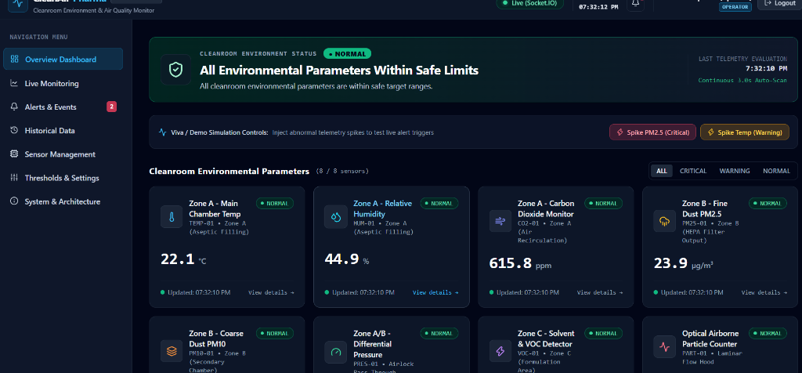
Figure 10.1: Clean Air Pharma Live Dashboard Output Screen.

10.2 Database Schema in pgAdmin 4
pgAdmin 4 verifies the connected PostgreSQL 18 cleanair_pharma database containing all five operational tables.
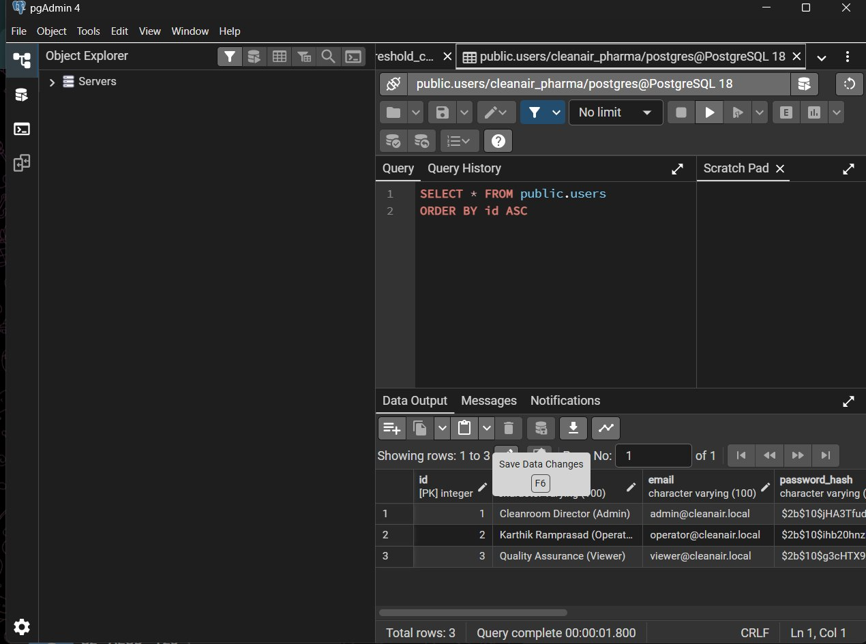

Figure 10.2: Verified PostgreSQL Schema in pgAdmin 4 Management Console.

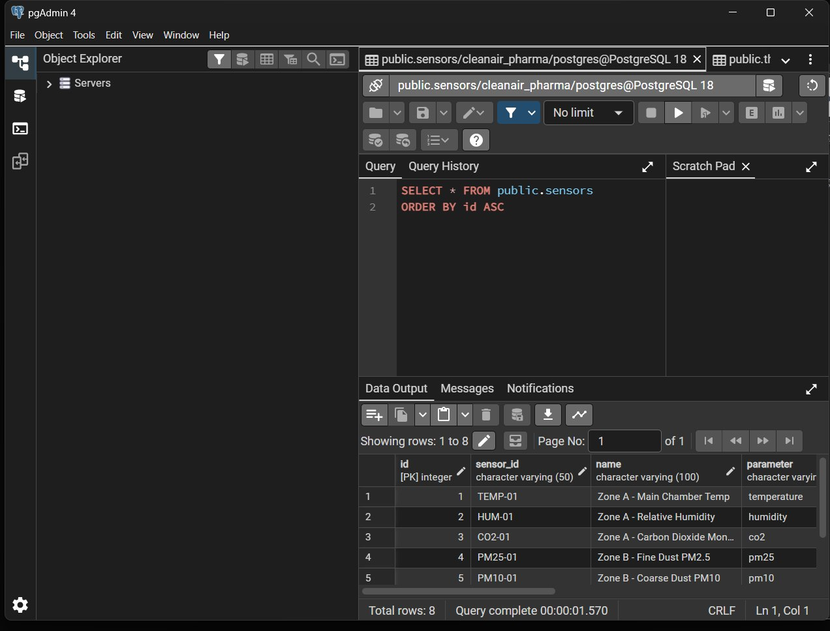
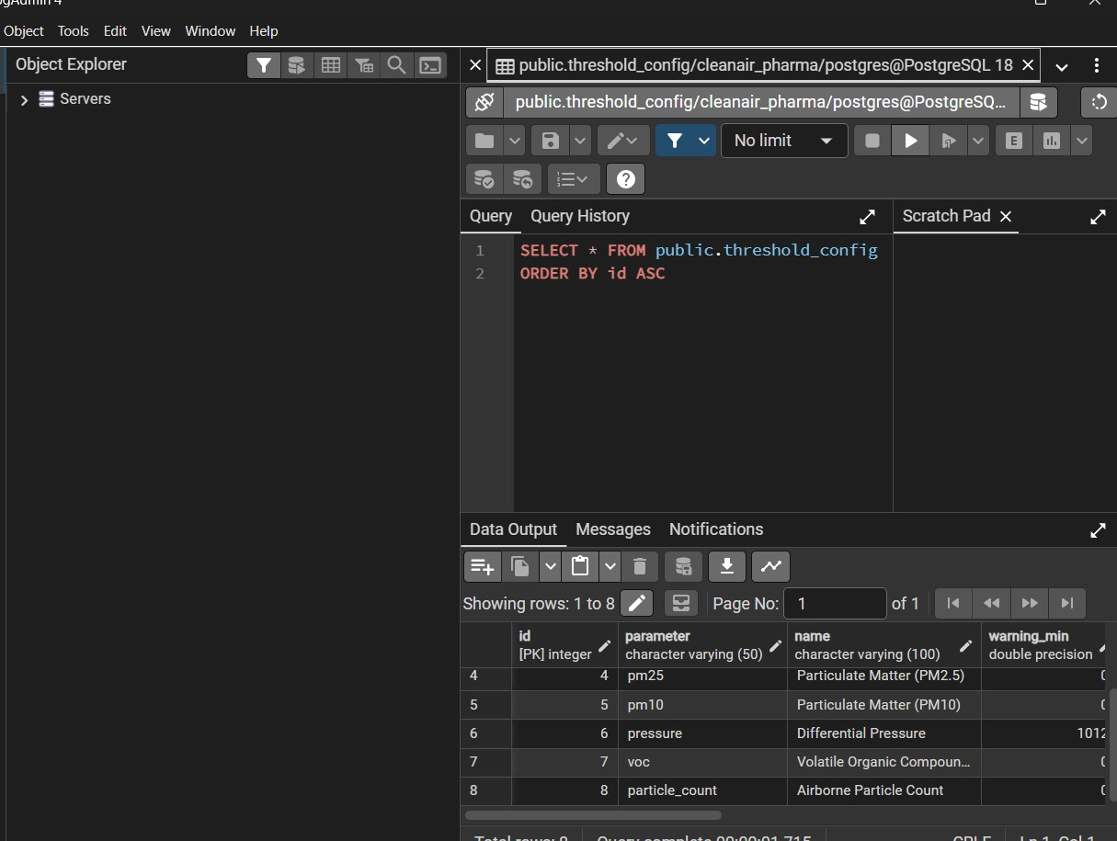

CHAPTER 11: TESTING AND VERIFICATION
The system was verified through systematic end-to-end testing across the full stack:
Test ID | Verification Scope | Expected Outcome | Execution Status
TC-01 | Frontend Vite Server | Vite dev server starts on port 5173 with HTTP 200 | Passed
TC-02 | Backend Express API | Server boots on port 5000 with healthy /api/health JSON | Passed
TC-03 | PostgreSQL Service & Pool | Node pg.Pool connects successfully to cleanair_pharma | Passed
TC-04 | Database Schema Verification | All 5 tables verified with active row counts | Passed
TC-05 | Telemetry Ingestion & Storage | Readings continuously inserted into sensor_readings | Passed
TC-06 | WebSocket Telemetry Stream | Socket.IO pushes telemetry updates every 3000ms | Passed
TC-07 | Threshold Excursion Engine | Abnormal readings trigger Warning/Critical alert events | Passed
TC-08 | Operator Alert Acknowledgment | PUT /api/alerts/:id/acknowledge updates database | Passed
TC-09 | CSV Data & Audit Export | History page downloads structured .csv file | Passed
TC-10 | Role-Based Access Control | Non-admin users blocked from hardware CRUD (HTTP 403) | Passed

CHAPTER 12: RESULTS AND DISCUSSION
The verification outcomes confirm that Clean Air Pharma operates as an effective supervisory monitoring application. Telemetry updates stream reliably every 3 seconds, threshold excursions flag within 500 milliseconds, and the PostgreSQL database maintains a complete relational audit trail.
CHAPTER 13: SECURITY AND LIMITATIONS
Security Safeguards: Passwords are protected via bcrypt hashing with 10 salt rounds; routes are governed by stateless JWT tokens; SQL injection is prevented through parameterized queries; and credentials reside in isolated environment files.
Project Limitations: Current telemetry is generated mathematically via MockSensorDataSource rather than physical microcontrollers; external SMTP and SMS dispatchers are not configured; and the system monitors a single cleanroom zone.
CHAPTER 14: FUTURE ENHANCEMENTS
Future enhancements include: (1) Physical ESP32 microcontroller integration over MQTT; (2) Multi-channel SMS (Twilio) and email (SendGrid) alert escalation; (3) Automated PDF compliance certificate generation; (4) Machine Learning predictive maintenance for HEPA filter degradation; and (5) Interactive multi-facility cleanroom floorplans.

CHAPTER 15: CONCLUSION
Clean Air Pharma demonstrates how modern full-stack web technologies and real-time WebSockets can modernize cleanroom environmental monitoring. By combining React 19, Node.js, Express.js, and an ACID-compliant PostgreSQL 18 database, the application replaces slow, error-prone manual clipboard logging with an automated digital supervisory platform.

REFERENCES
1. Meta Open Source, "React: The Library for Web and Native User Interfaces," https://react.dev/ 2. OpenJS Foundation, "Node.js v24 API Reference & Architecture Documentation," https://nodejs.org/docs/ 3. Express Framework Team, "Fast, Unopinionated, Minimalist Web Framework for Node.js," https://expressjs.com/ 4. The PostgreSQL Global Development Group, "PostgreSQL 18.6 Documentation," https://www.postgresql.org/docs/18/ 5. Socket.IO Team, "Bidirectional and Low-Latency Communication for Every Platform," https://socket.io/docs/v4/ 6. Y. Evan and Vite Contributors, "Next Generation Frontend Tooling," https://vite.dev/ 7. Tailwind Labs Inc., "Utility-First CSS Framework," https://tailwindcss.com/docs 8. International Organization for Standardization, "ISO 14644-1: Cleanrooms and Associated Controlled Environments," ISO 14644-1:2015. 9. European Commission, "EU Guidelines to Good Manufacturing Practice: Annex 1 - Manufacture of Sterile Medicinal Products," EudraLex Vol 4, 2022. 10. Internet Engineering Task Force (IETF), "JSON Web Token (JWT) Standard," RFC 7519, 2015.

